Hi!

Below are the steps to grant Clearstone access to your Facebook ad account.

1. Click this link, Ad Account Settings, to open your Facebook Ads Manager. You may be asked to re-enter your Email or Phone Number and Password.

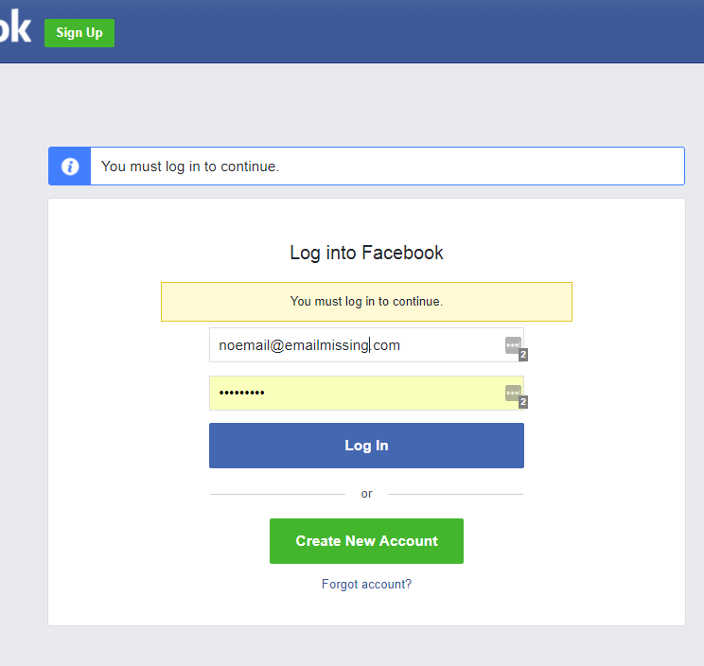

2. Once your Facebook Ads Manager has loaded, copy your Facebook Ad Account ID.

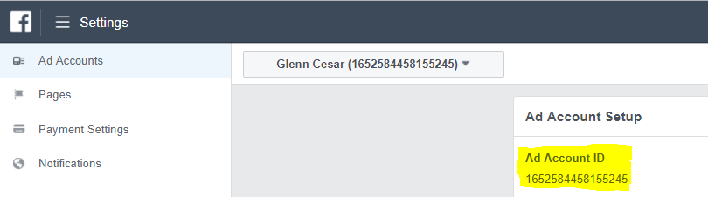

3. Send your Facebook Ad Account ID to us at Clearstone. We will then send a request to manage your Facebook ad account. Once we have requested access to your account, you will get a notification on Facebook (and also an email).

4. Log into your personal Facebook account and click the Notifications icon. Then click “Clearstone has requested access to your ad account” notification in the drop-down menu.

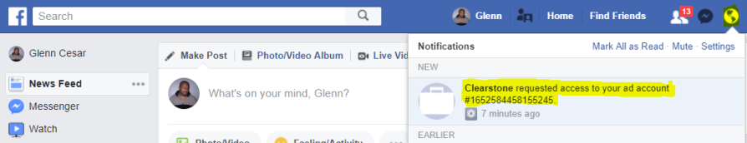

Or, click the link in your email to open your Facebook Ads Manager.

5. In the “Ad Account Roles” section of your "Ad Accounts" page, click “Respond to Request”.

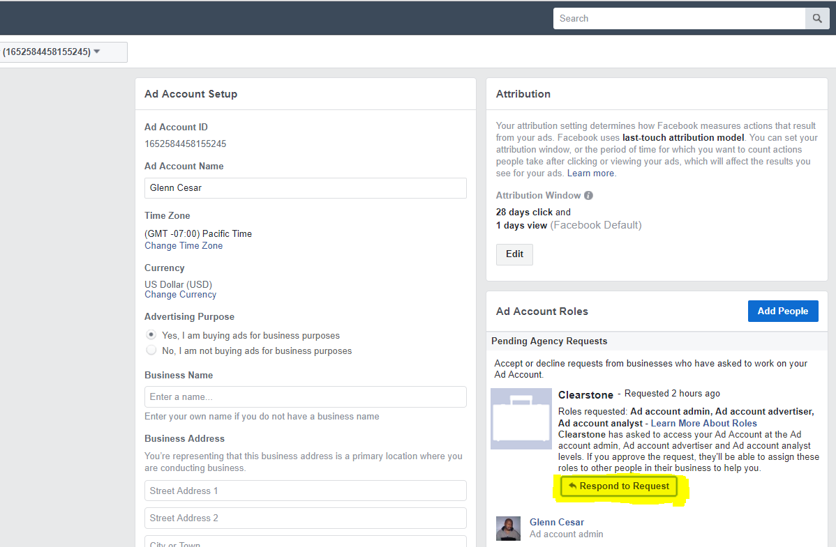

6. In the pop-up window, click the “Give Clearstone access to my AdAccount” button.

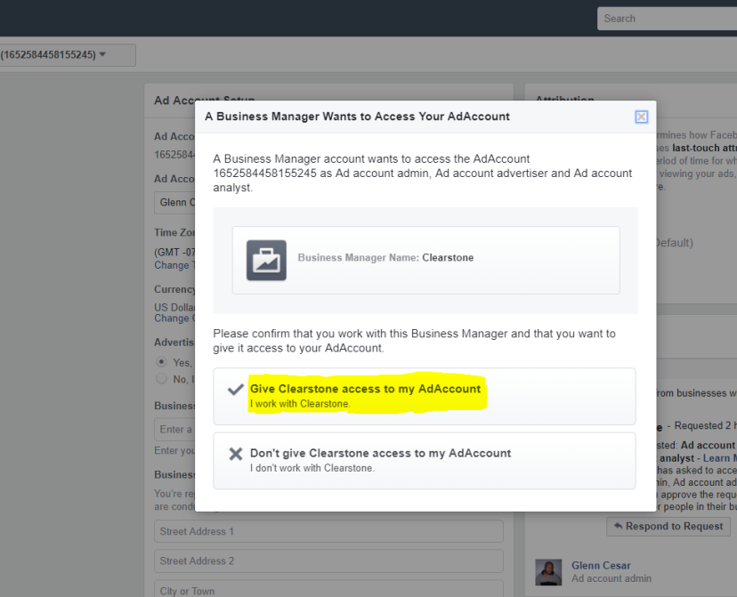

7. Clearstone will then have access to manage your Facebook ad account.

IF you cannot locate the request in your notifications center or your email, here is another way to locate the access through your personal page:

- Login to Facebook

- Click on the dropdown Located in your Upper Right Hand Corner:
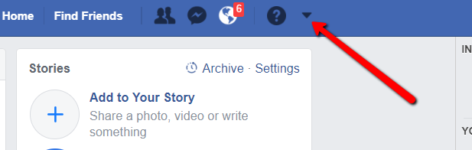

- Click on Your Ad Account

- Go to Settings Gearbox in your upper right hand Corner Pictured Below:
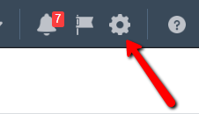
- In the “Ad Account Roles” section of your "Ad Accounts" page, click “Respond to Request”.
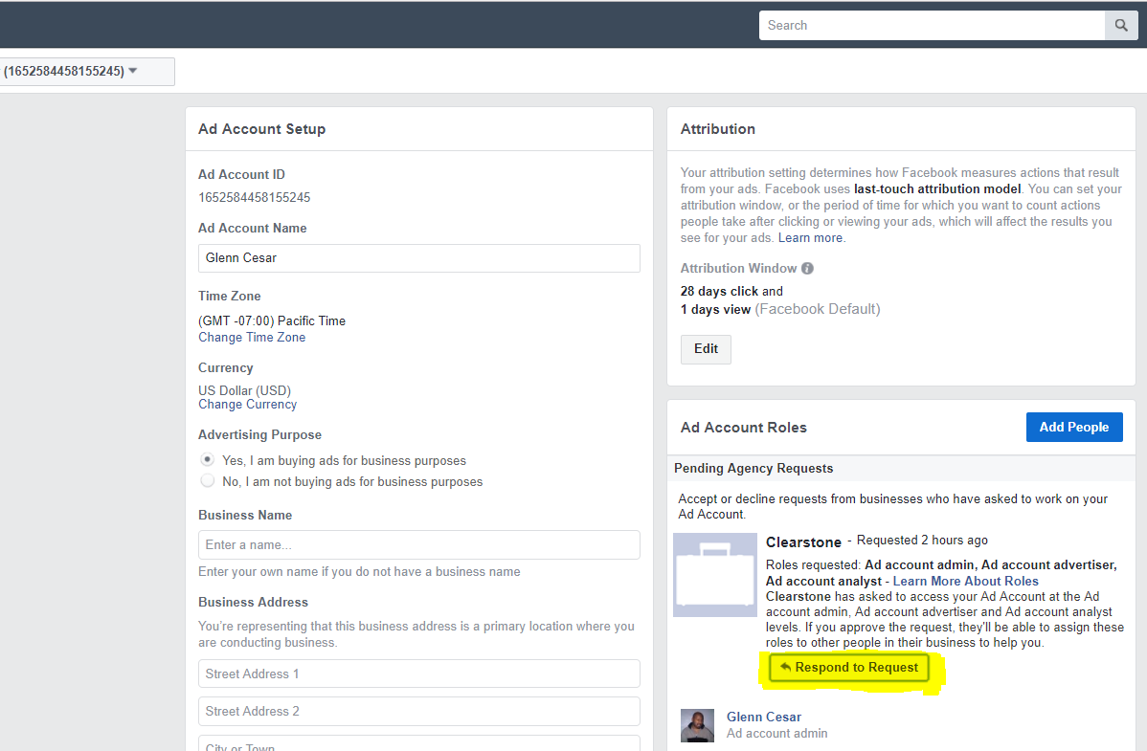

- In the pop-up window, click the “Give Clearstone access to my AdAccount” button.
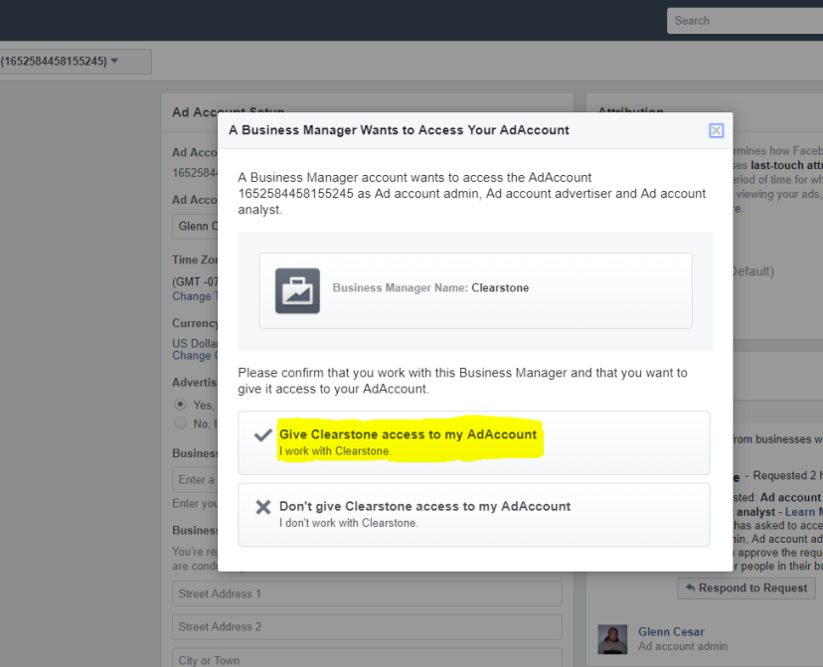

If you have any questions, please let me know.

Thank you,

